Open the browser and type following link in address bar:

http://localhost:8080

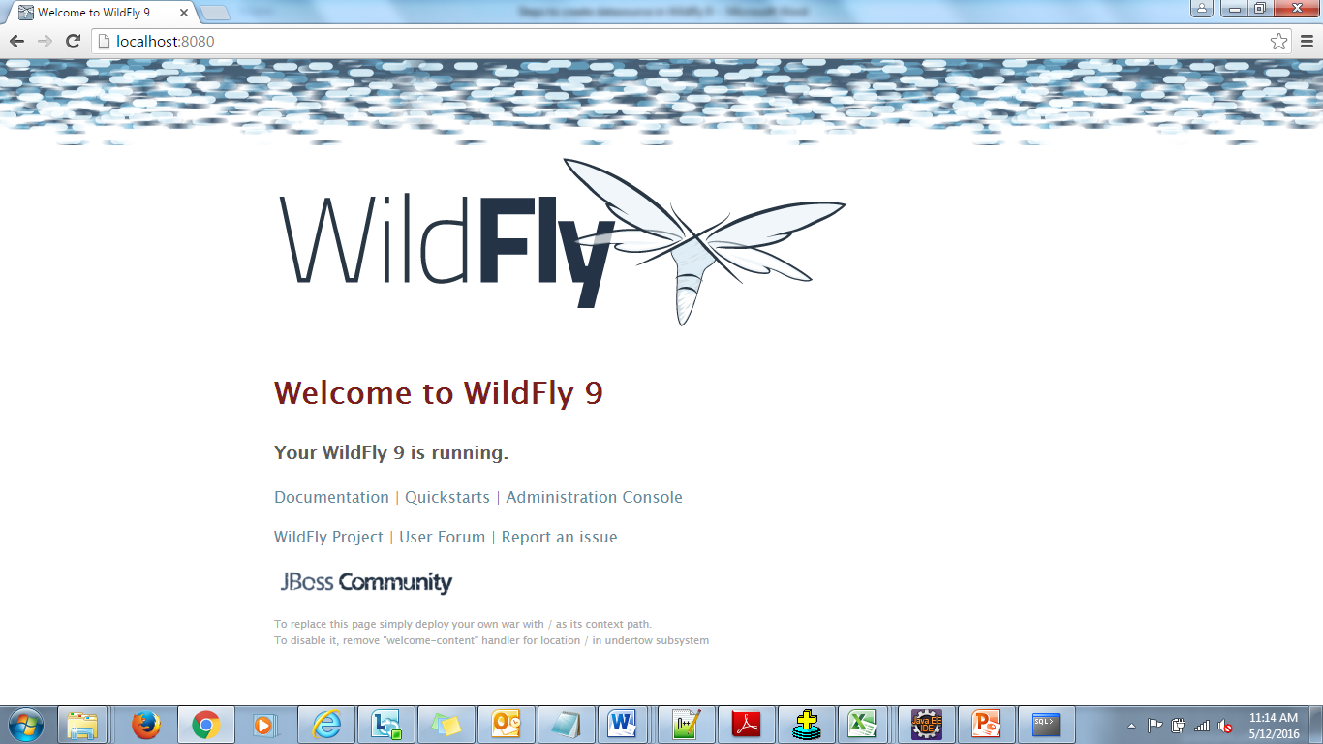

Click On the Administration Console Link

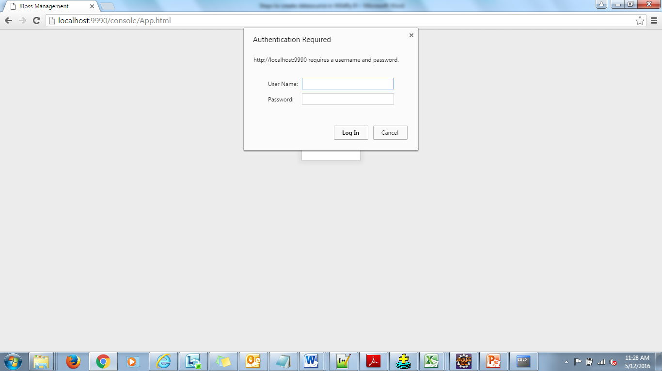

Enter the Username and Password for Admin console.

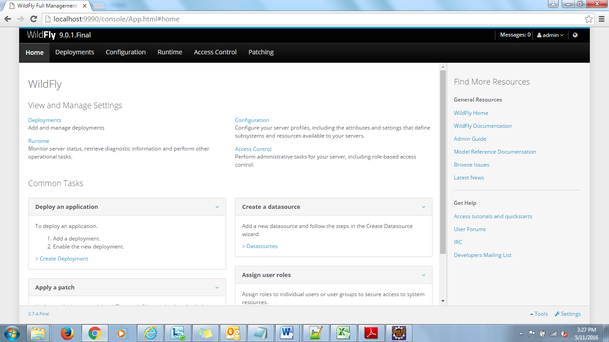

Click on Deployment Tab

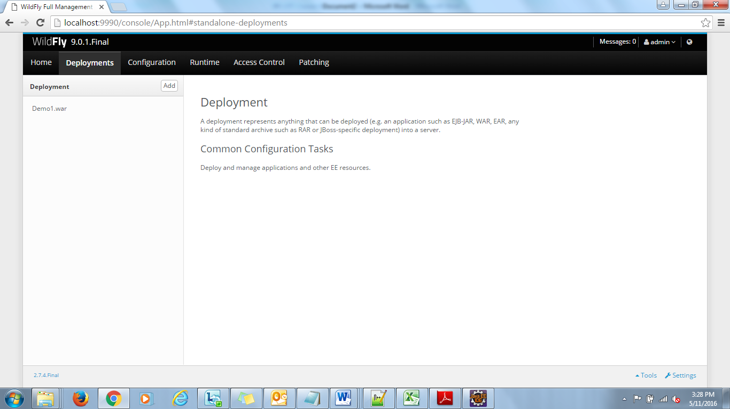

Click on Add button

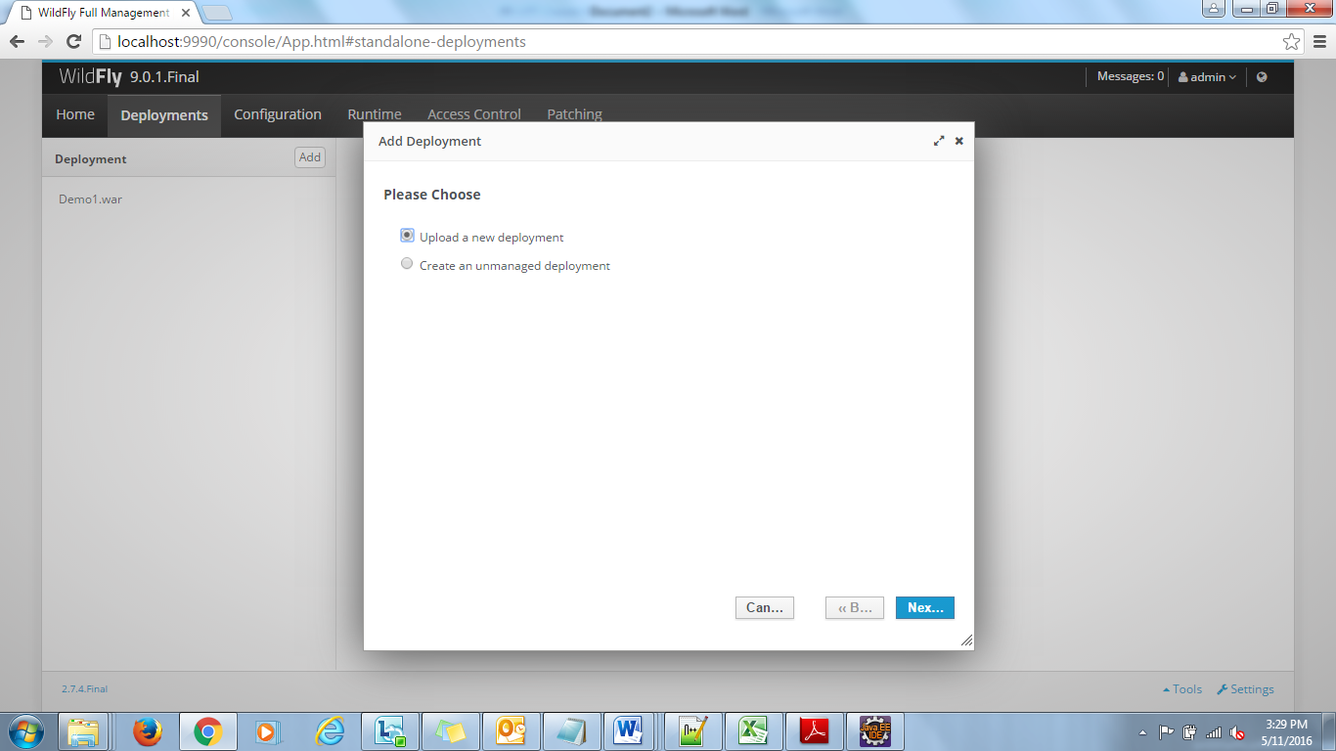

Select upload a new deployment radio button and click on Next.

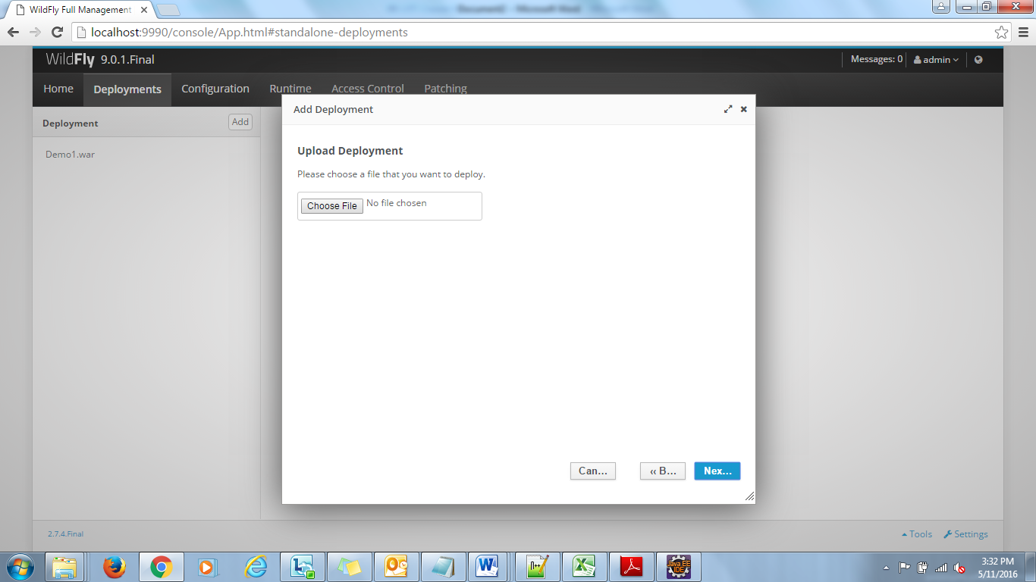

Click on Choose File button.

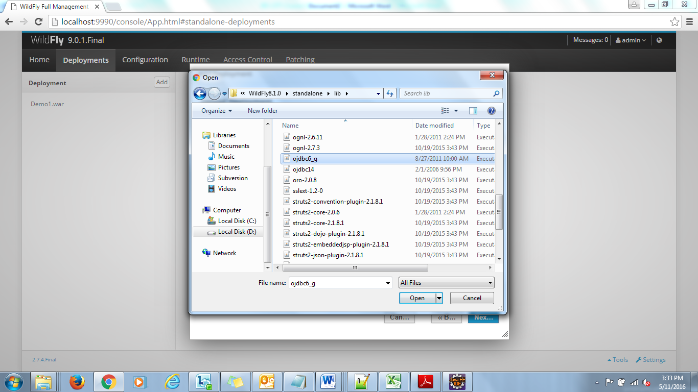

Select ojdbc6_g.jar file and click on Open button.

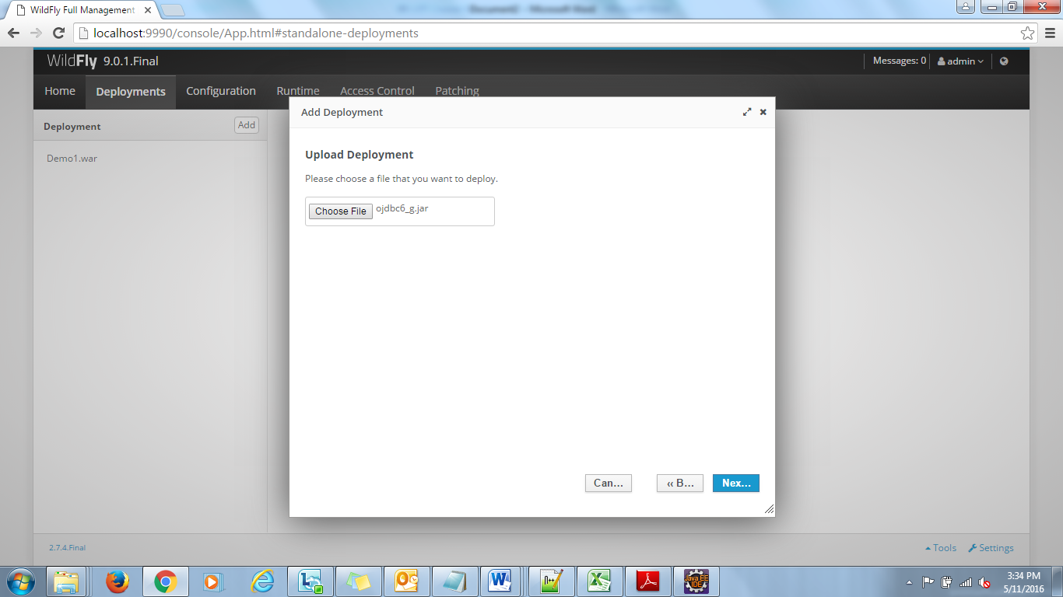

Now Click on Next button.

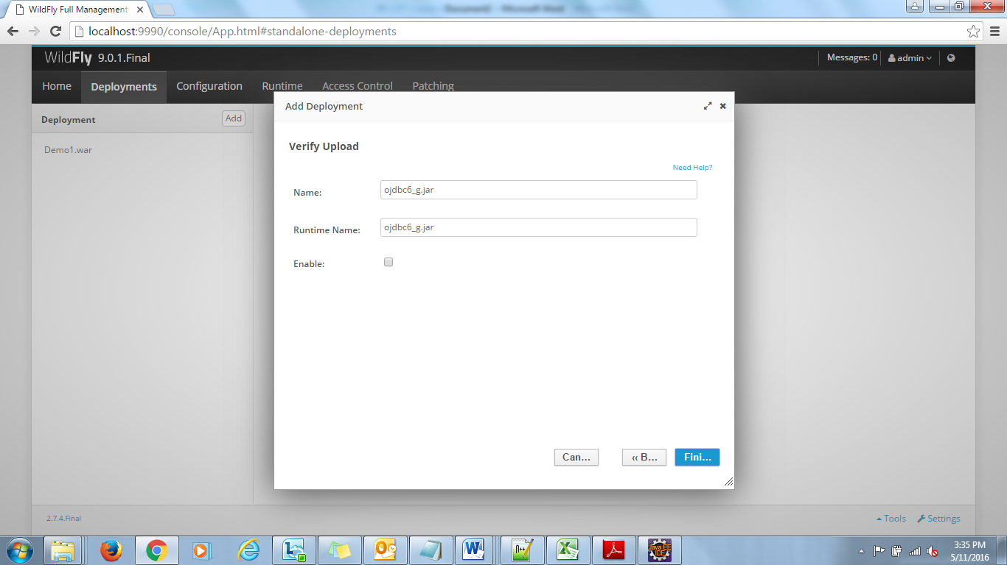

Now click on Finish button.

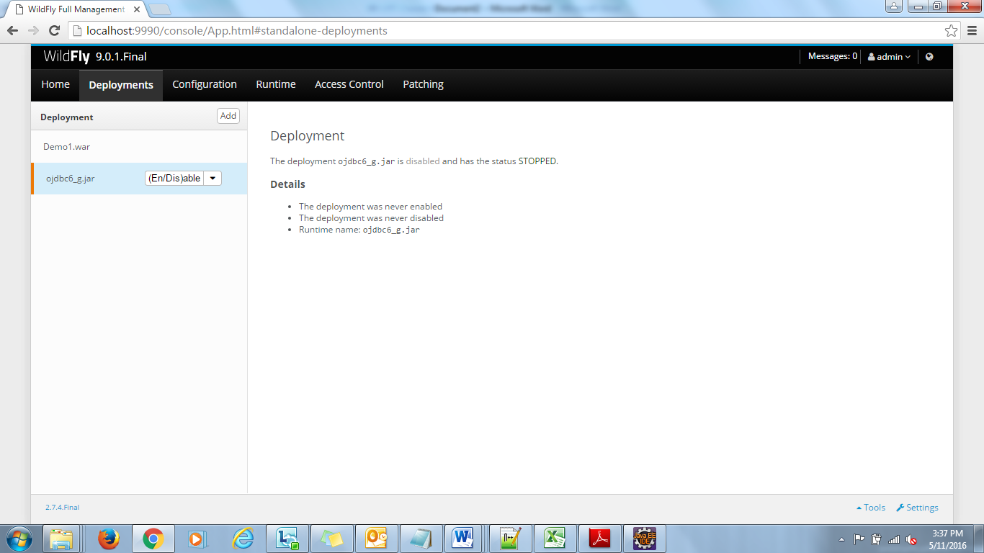

By default the status is STOPPED.

Select ojdbc6_g.jar and click on (En/Dis)able button.

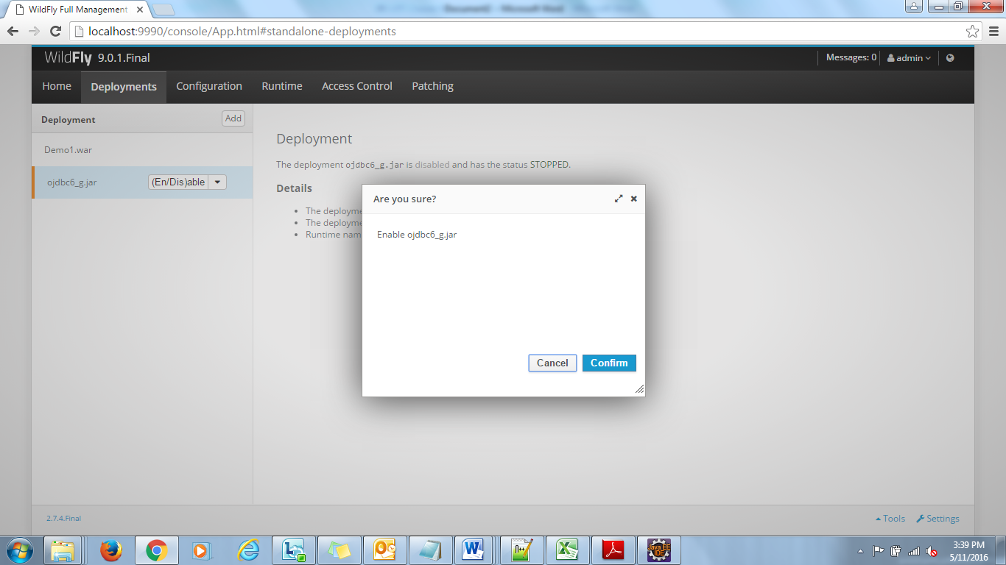

Click on Confirm button.

Again select the ojdbc6_g.jar and check the status OK

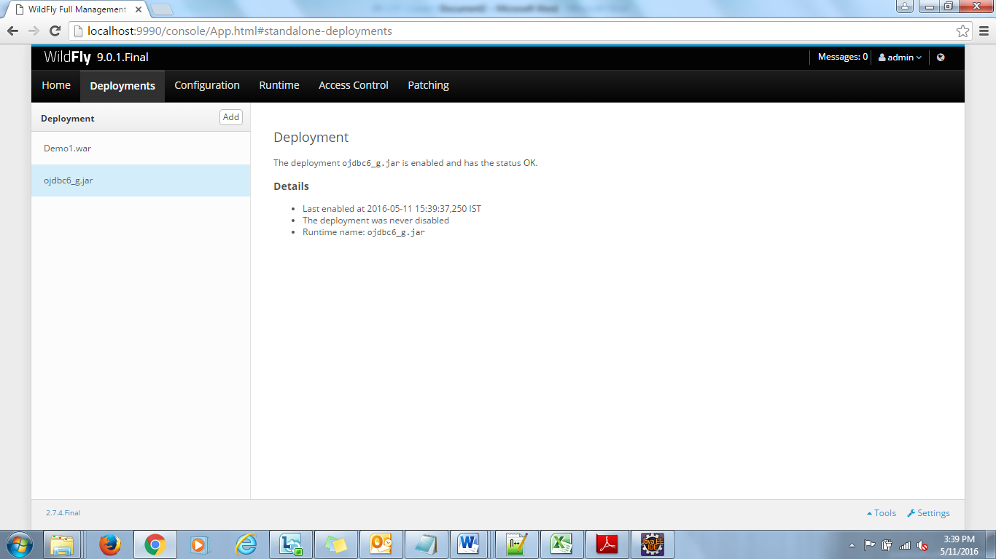

Now click on Home tab.

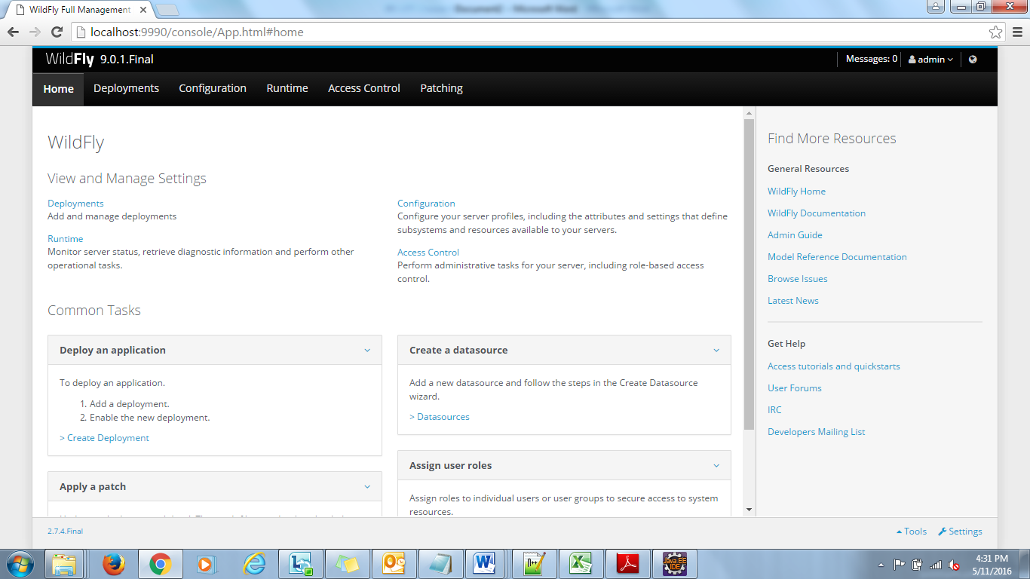

Click on Datasources Link.

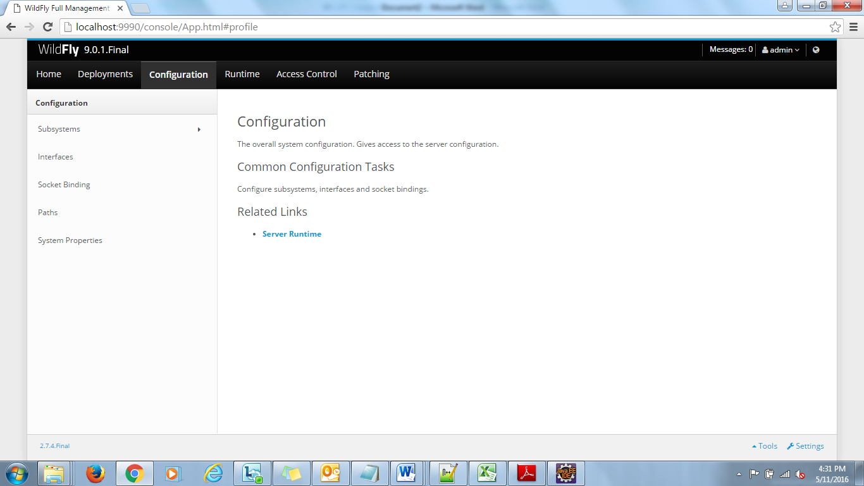

Click on Subsystems.

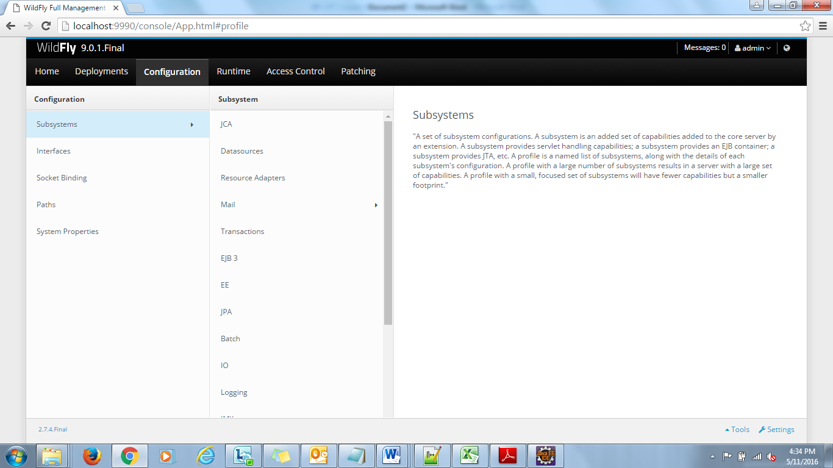

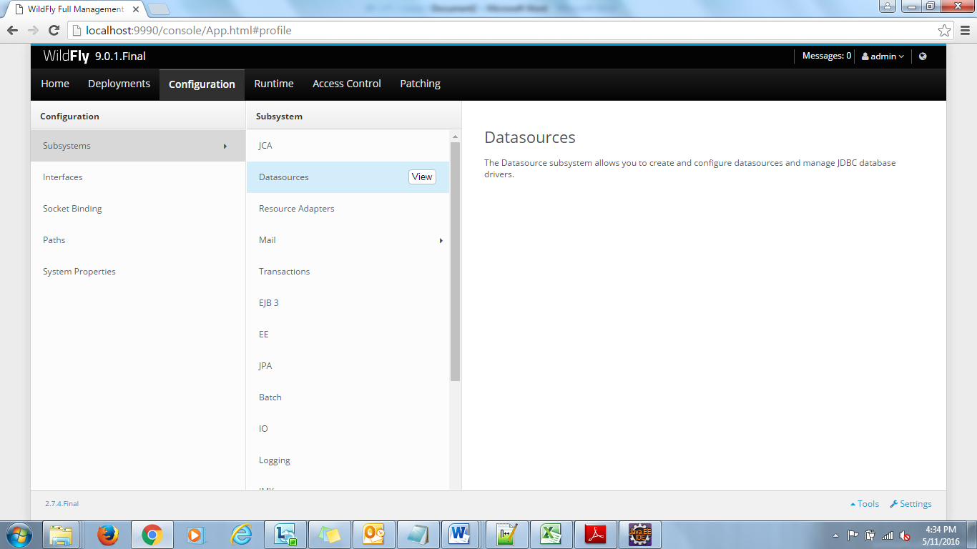

Now Click on Datasources View button.

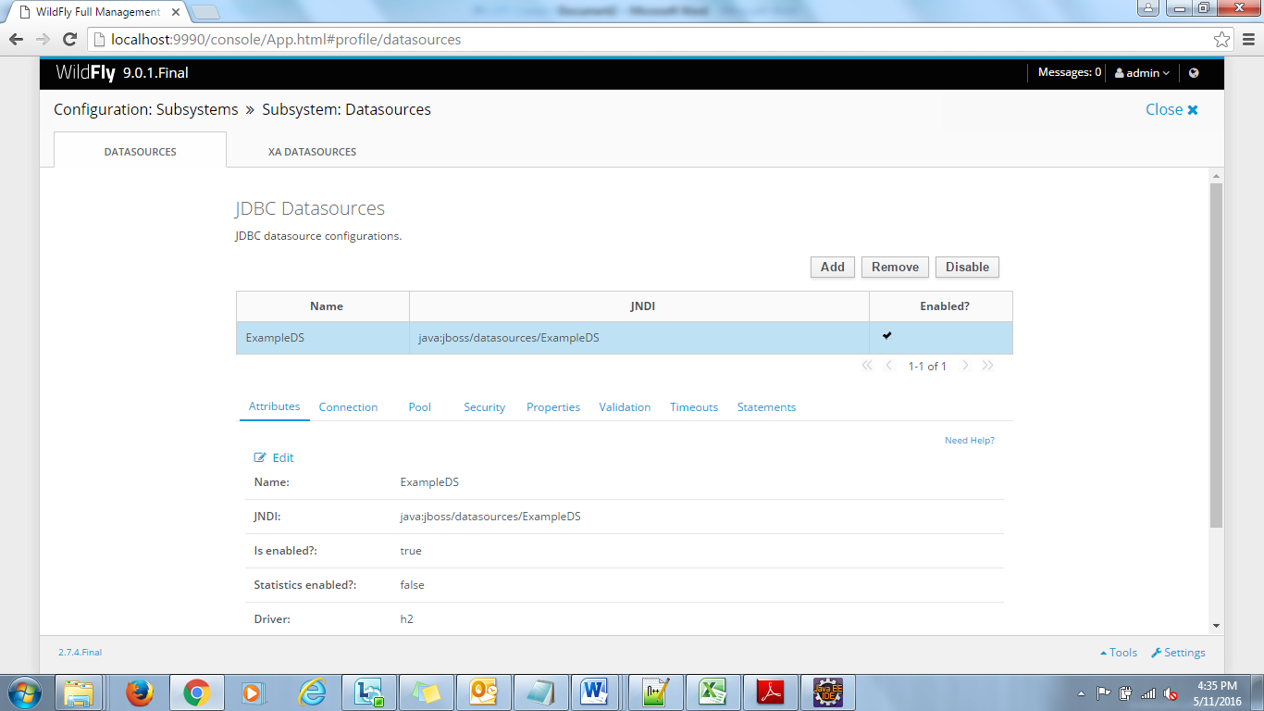

Click on Add button.

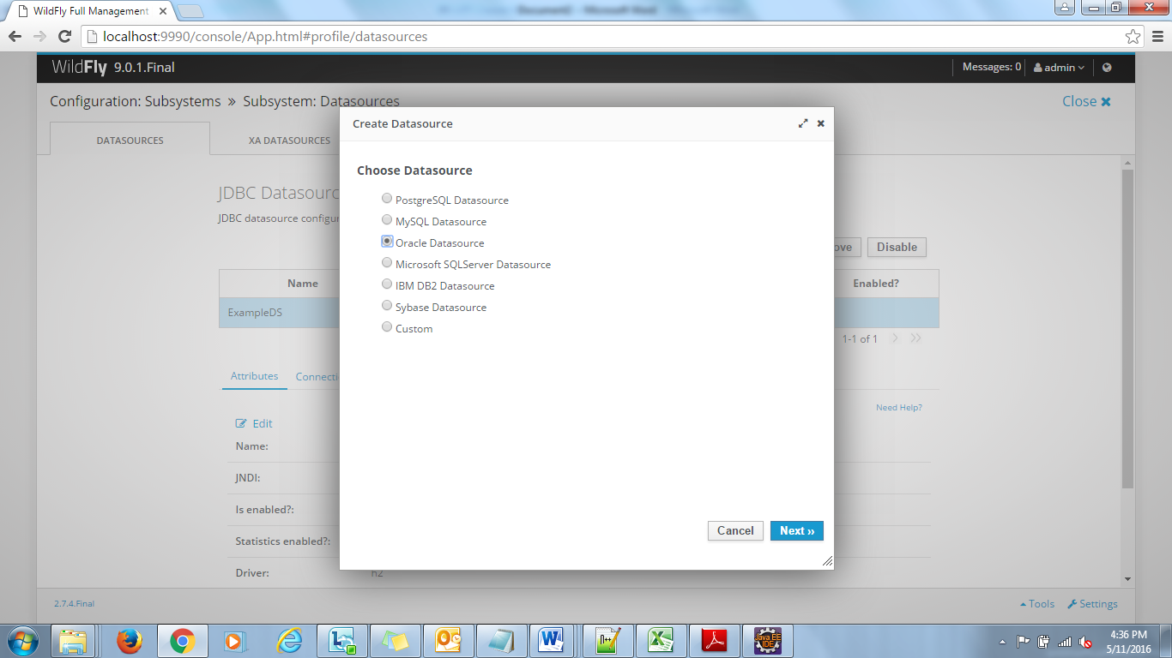

Select Oracle Datasource (or Custom) radio button and click on Next button.

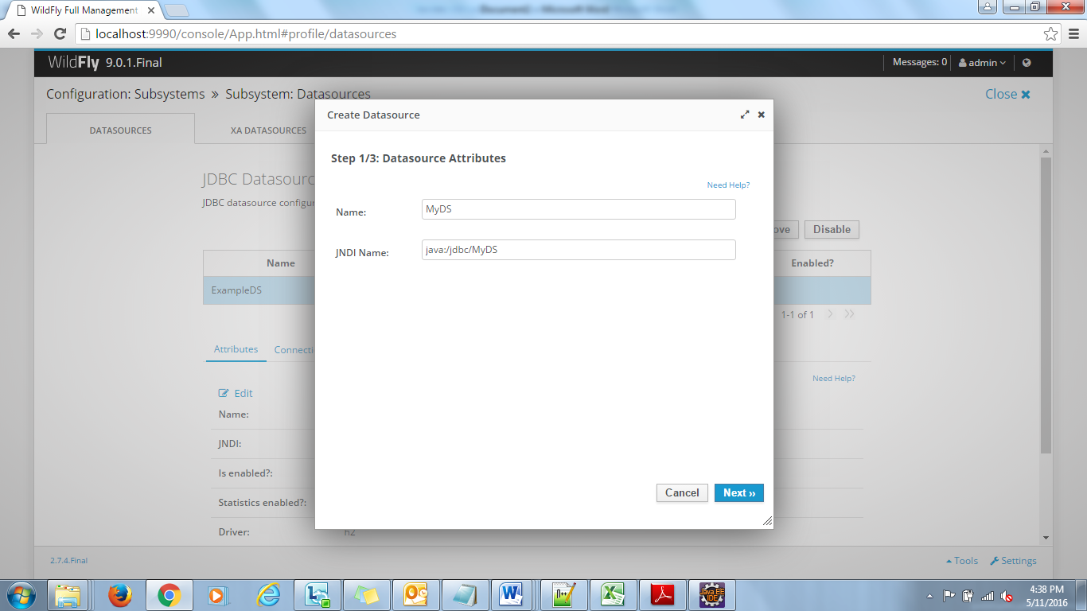

Give Name and JNDI Name then click on Next button.

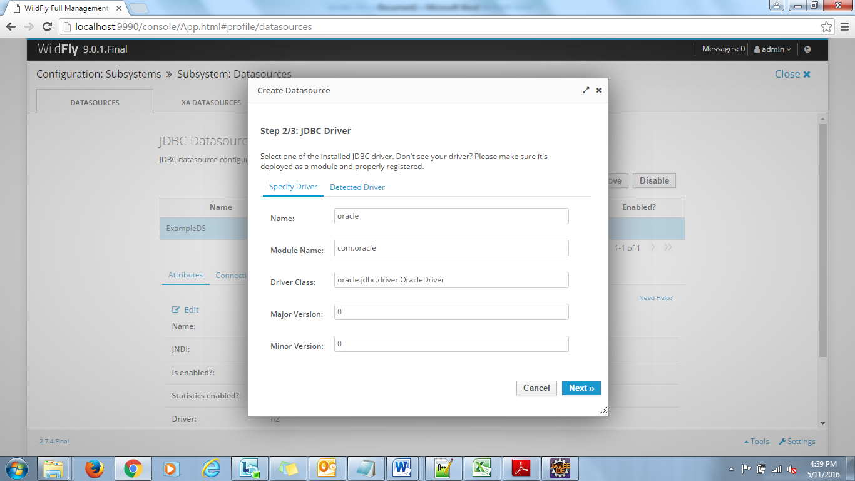

Now click on Detected Driver Tab.

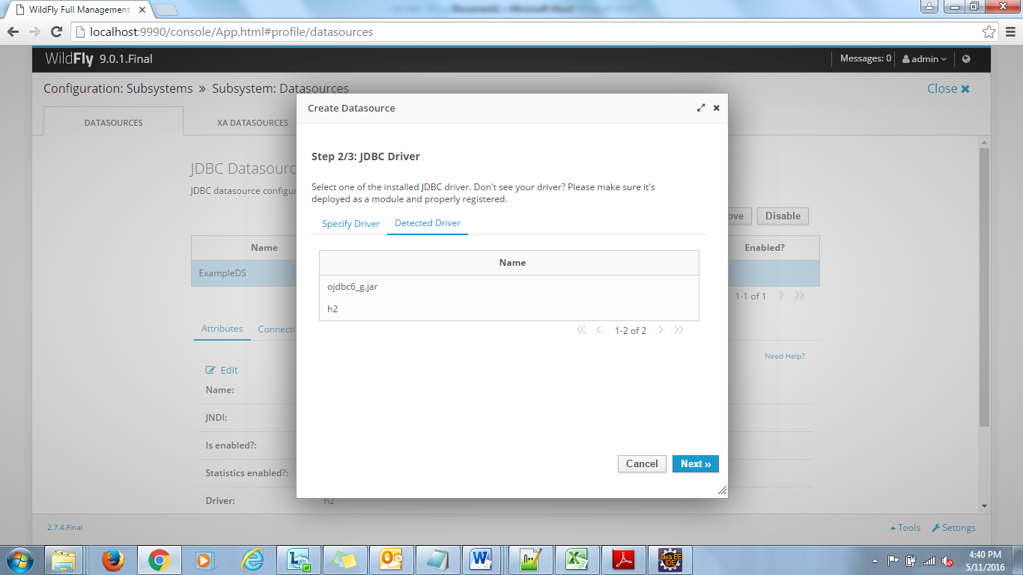

Here select ojdbc6_g.jar from the list.

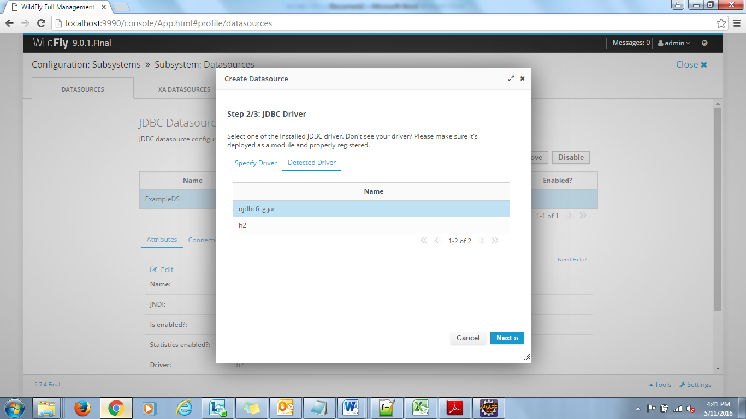

Now click on Next button.

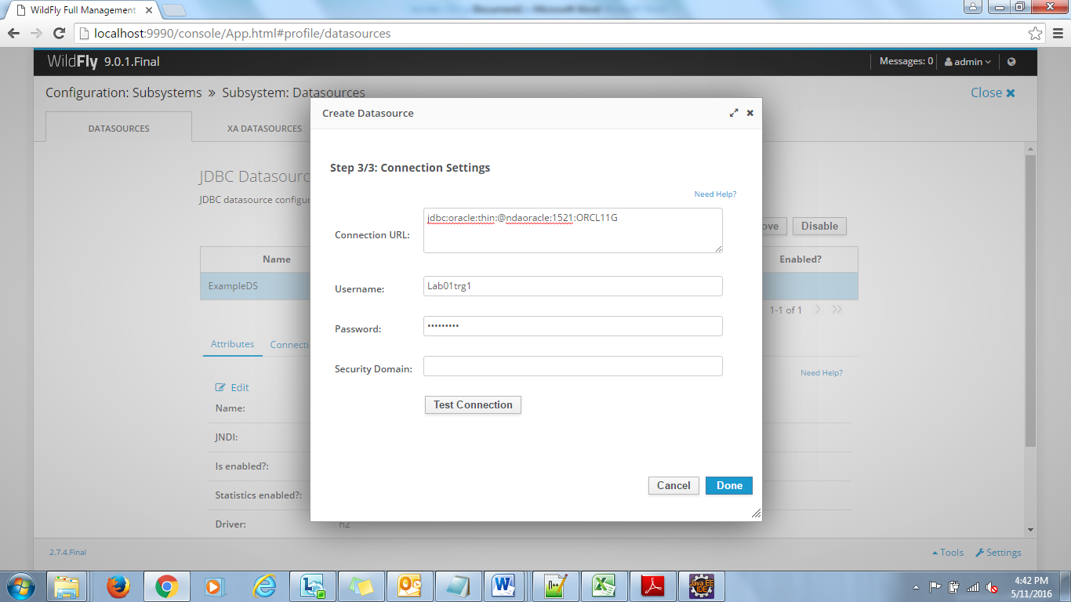

Specify the url and Oracle credential and click on Test Connection button.

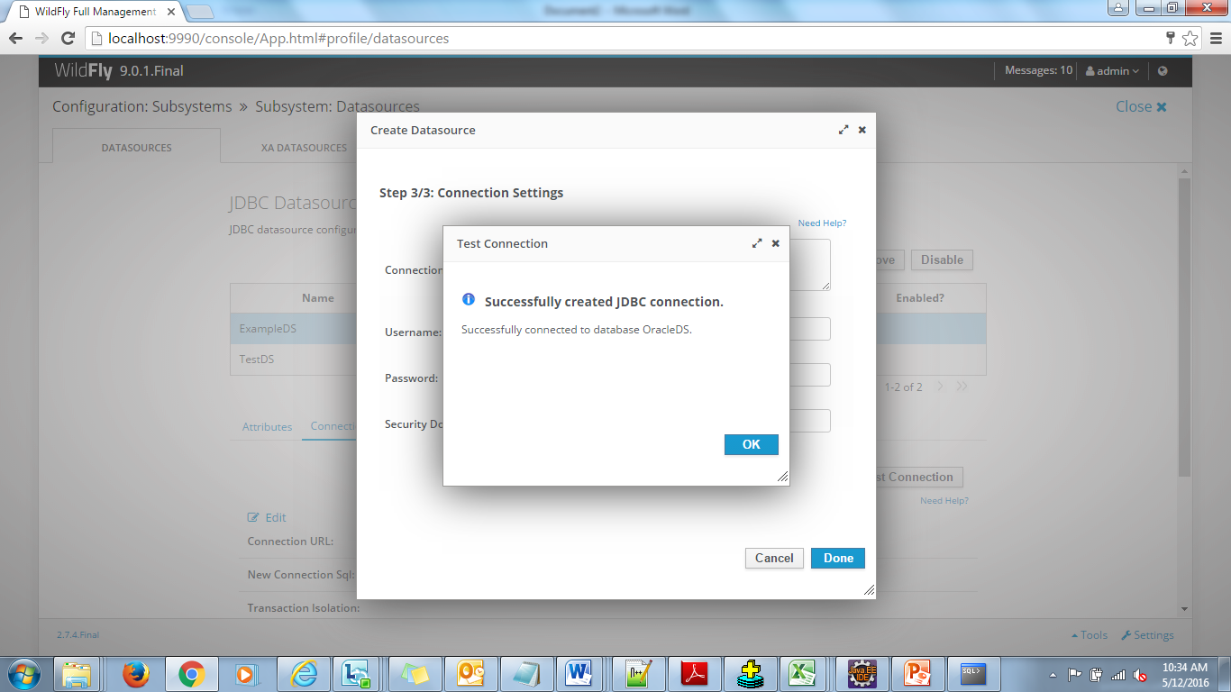

Click on OK button

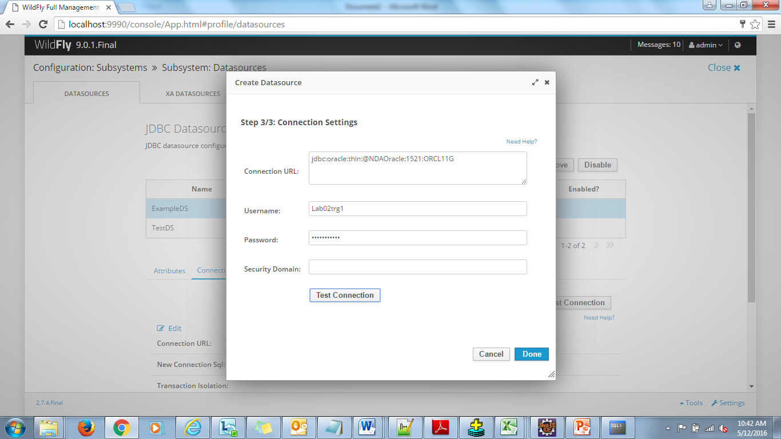

Now click on Done button.

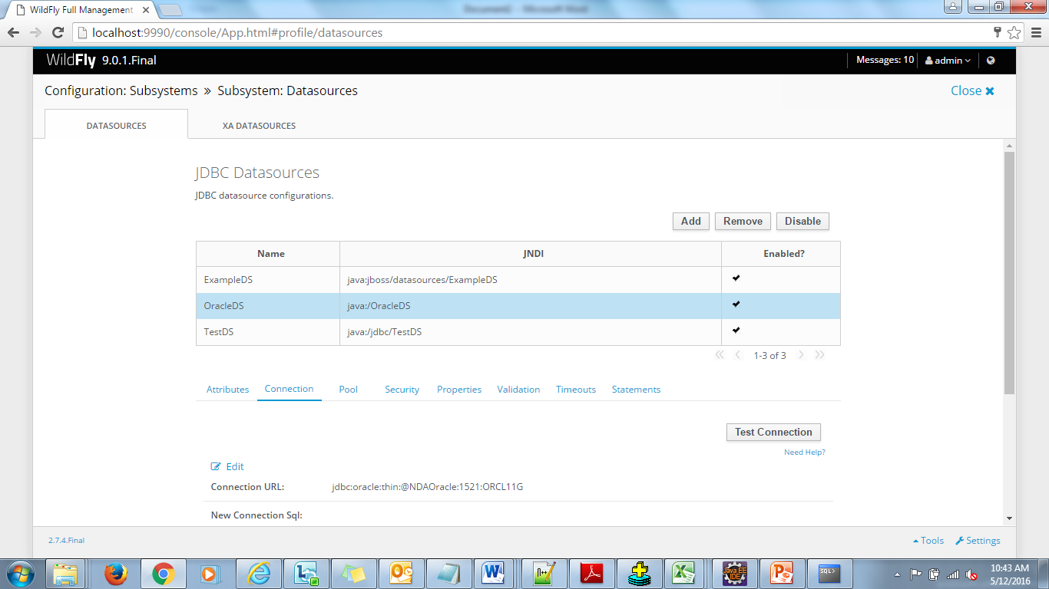

If you want to update any settings in Datasource following steps to be done.

1. Select the Datasource
2. Disable the Datasource.
3. Go to Appropriate link such as Connection or Security
4. Click on Edit button.
5. Modify details
6. Click on Save button.
7. Enable the datasource.